9.3HD

COS10009

Introduction to programming

**Thanh Minh**

**Student ID: 103809048**

Code Explanation document

Swinburne University of Technology

1. **Program’s Window and implement some features**

Figure 1: set up the ZOrder to arrange the layers for later uses in the program

Hidden will be at the back of the program when I want to hide content and create the effects so that the program can have a better looking.

I have created the constant HEIGHT(800) and WIDTH(1500) for the size of the window, and put it on the top of the file so that everyone can see clearly.

Figure 2: set up for the window

If I change false into true, the program’s window will be played in full screen. I also create an array for Player for displaying ships in the Selecting page.

Figure 3: End code of program

Without these 2 lines of code, the program cannot run so I must include it in every single Gosu program.

Figure 4: States and procedures of Update for program

Figure 5: States and procedures of Draw for program

First I will have to set the @scene = :start so that the program will start at the entry page and will call all the procedures related to start such as draw_start, update_start, …

I must have each screen of the program, it should have different functions so that can increase the efficient of the code, make the program run smoother, faster. The code is also can be visualized easily.

1. **Entry page**

First, I need to set up in order to draw up the entry page for the program.

Figure 6: Setup for the entry page

I need to set @scene = :start by default so that the program can start and draw the entry page first. I also nneed to import some sounds and musics into my program. I also define the font size for drawing title, description of the program so that the user can know what is on the screen.

For the @hover_options_1,2,3 , I will use it for creating effects while suffering through options so that the user can feel like the program is make with a lot of effort.

For two images that I have imported, start.jpg is for the background of the screen to decorate the screen. The other one is for pointing at the current option (there are some RPG using this function for their menu)

Figure 7: draw_start procedure

After importing background image, I need to draw it so that it can display, but I will make the ZOrder of it is Background so that it won’t hide other contents.

I have made the ZOrder of @point and @hover_options_1,2,3 are hidden so that @point and black rectangle won’t display on the screen until their ZOrder are changed.

Figure 8: update_start procedure

In figure 8, I have set up for the effects when suffering through options, the black box and the pointing rocket will be displayed at the current option like in figure 9

Figure 9: Entry page

Figure 10: button_down_start procedure

For this procedure, when I press the left mouse button or use Enter at the current option, it will direct me to the next page. When I choose the Play option, the start music will be played to announce me that I have entered the next stage of the game. And when I choose to close the program just choose the Exit option then the program will close immediately

1. **Instruction page**

Figure 11: set up for the instruction page

Before moving forward, I need to import music and background image for this page.

Figure 12: draw_instruction for the instruction page

For this procedure, mainly I draw the background image and the description for the user to read how to play this game. So that the user can understand more about the program.

Figure 13: Instruction page

Figure 14: Update_instruction for instruction page

This page is the easy page to be created among all the pages so in the update_instruction there is no code but if I have time to develop this project more, I will decorate more thing on this page and adding effects. Because there are some programs, games that in the instruction page, their page are so interactive and clearly show how the game work.

Figure 15: button_down_instruction procedure for instruction page

When the user wants to exit and go back to the previous page, they can press Q or Space to go back.

1. **Selecting page**

At all the start of each page, I need to set up things for later use.

Figure 16: Set up for Selecting page

After setting up, I also need to include the array for player for drawing it.



Figure 17: Add array for player

After importing the media files, I need to draw out what I have set up above in the draw_selecting.

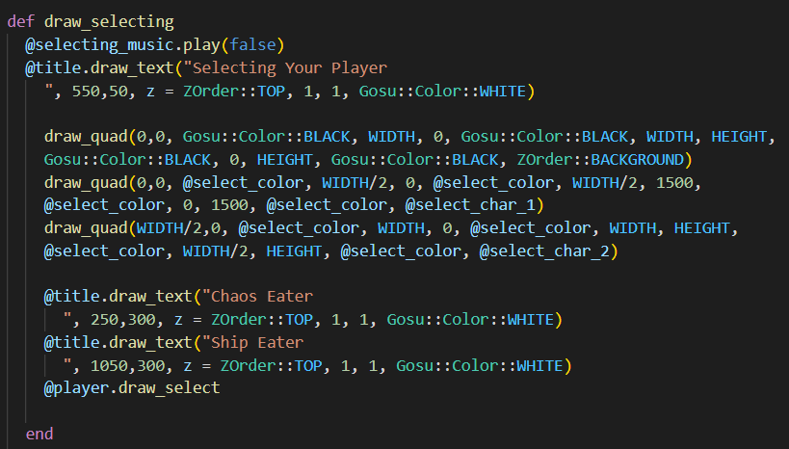

Figure 18: draw_selecting procedure for my program

For the first quadratic shape, I made its color Black and the ZOrder is Background and for the next two quadratic shapes I made it hidden so that when the user is choosing the player, the current option shape will be go up with the color of grey.

With the @player.draw_select, I will call the draw_select procedure for the array Player in another file so that the player can be drawn out.

Figure 19: Array for Player

Above is the array of player I have created in another file to keep the main file shorter and clear.

Figure 20: update_selecting procedure

With those lines in the figure 20, the current option will be visualized for the user to see whenever they want to choose which player.

Figure 21: selecting page

The current option is chaos eater so the box on the left will be grey.

Figure 22: button_down_selecting procedure

With this procedure in figure 22, the program will know what the next step is when the user has chosen the player. The new array will be created depend on which ship the user choose and it will call exact what the user has chosen.

1. **Play and ending page**

For these 2 stages, I am developing it so I will show it later on.